Determining the K_{a} of an Acid from pH Measurements
Troy University Chemistry Faculty
Licensed under a Creative Commons Attribution-ShareAlike 4.0 International License.

Introduction
Strong acids, like HCl(aq), completely dissociate:
HCl(aq) + H₂O(l) → H₃O⁺(aq) + Cl–(aq)
On the other hand, weak acids, like acetic acid, only partially dissociate; the dissociation can be written as an equilibrium:
HC₂H₃O₂(aq) + H₂O(l) ⇌ C₂H₃O₂–(aq) + H₃O⁺(aq)
Because this is an equilibrium, an equilibrium constant is associated with it:
$K_{a}=\frac{\left[C_{2}H_{3}O_{2}^{-}\right]\left[H_{3}O^{+}\right]}{\left[{HC}_{2}H_{3}O_{2}\right]}$.
Determining the numerical value of K_{a} in this lab requires knowing the concentration of H₃O⁺, [H⁺]. The range of hydrogen ion concentrations that are routinely encountered in the laboratory is enormous: from around 18 M for concentrated acids to 1 × 10⁻¹⁵ M for concentrated bases. To handle such a wide range of values, [H⁺] is commonly reported as “pH”, which is defined as the negative logarithm of [H⁺]:
pH = –log([H⁺]) Eq (1)
The pH of a solution can be measured with a pH meter that uses “glass electrodes” to measure a voltage in a solution. The voltage is proportional to the logarithm of [H⁺], so it was convenient to define a pH scale in terms of logarithms.
The logarithm is the exponent needed to express a number as a power of 10. For example, 0.001 M can be written as 1 × 10⁻³ M. The logarithm of 0.001 is –3.0, so the pH of a solution that is 0.001 M is 3.0 (pH has no units). Because fractional exponents are possible, any positive number can be written as an exponent. For example, 0.025 can be written as 10^{–1.60}, so a solution that is 0.025 M has a pH of 1.60. To show this with a calculator, enter .025 and push the log button (not the ln button), and the display should show –1.602. Then, push the 10^{x} key, and the display should show the original number of 0.025. (The key strokes are a little different if you have a graphing calculator.)
In this lab pH will need to be converted back to [H⁺]. The formula for that is
[H⁺] = 10^{-pH} Eq (2)

Determining K_{a} from the pH of an Acid Solution of Known Concentration
The chemical reaction for this equilibrium is:
HA(aq) + H₂O(l) ⇌ H₃O⁺(aq) + A–(aq) $K_{a}=\frac{\left[H_{3}O^{+}\right]\left[A^{-} \right]}{\left[HA\right]}$
Example 1: Suppose a solution is prepared by dissolving an unknown acid in water such that the molarity of the acid is 1.00 M. The pH of this solution is measured and found to be 2.36. The equilibrium concentrations of all species will be determined using an ICE table.
The initial molarity of HA is 1.00 M. No information is given about the initial concentrations of H₃O⁺ and A–, so their initial concentrations are assumed to be zero. That completes the first line of the ICE table, below. The equilibrium molarity of H₃O⁺ is found using Eq (2) to be 0.0044 M. Although it is not obvious, the equilibrium concentration of A⁻ is also 0.0044 M. To see this, consider the H₃O⁺: it was initially 0, but increased to 0.0044 M; it had to come from somewhere. It came from dissociation of the HA. But every HA that dissociates also produces an A⁻, so the equilibrium concentrations of H₃O⁺ and A– must be equal, since they were both zero initially.
Table 1. An ICE Table
 | HA(aq) + H₂O(l) | ⇌ | H₃O⁺(aq) | + | A–(aq)
Initial conc. / M: | 1.00 |  | 0 |  | 0
Change in conc. at equilibrium / M:
Equilibrium conc. / M: |  |  | 0.0044 |  | 0.0044
The ICE table can then have the changes entered. The change in reactant HA is opposite in sign of the change in the two products. That is, if [A–] increased, then [HA] must have decreased.
 | HA(aq) + H₂O(l) | ⇌ | H₃O⁺(aq) | + | A–(aq)
Initial conc. / M: | 1.00 |  | 0 |  | 0
Change in conc. at equilibrium / M: | –0.0044 |  | +0.0044 |  | +0.0044
Equilibrium conc. / M: | 0.9956 |  | 0.0044 |  | 0.0044
The equilibrium concentration of HA is calculated by adding the change to the initial concentration, giving 0.9956 M.
Now that all the equilibrium concentrations are known, the value of K_{a} can be calculated from the three equilibrium concentrations:
$$K_{a}=\frac{\left[H_{3}O^{+}\right]\left[A^{-} \right]}{\left[HA\right]}=\frac{\left[0.0044\right]\left[0.0044\right]}{0.9956}=1.9×{10}^{-5}$$

K_{a} from Partial Neutralization
In this section the equilibrium constant for one reaction will be calculated for solutions with a wide range of concentrations. If the values of K_{a} are all about the same, that will demonstrate that the equilibrium is accurately described by the equilibrium constant expression.
To form the solutions with the various amounts of HA and A–, each solution will start with the same amount of HA to which different amounts of sodium hydroxide are added. The hydroxide will neutralize some of the HA, converting it into its deprotonated form, A–:
HA(aq) + OH–(aq) → A–(aq) + H₂O(l) Eq (3)
Moles initially: 6 0 0
Moles of OH– added: 2
Resulting moles: 4 0 2
To illustrate, suppose that 6 moles of HA are present initially. To this solution is added 2 moles of NaOH, which pulls a proton off of the HA, leaving only 4 moles of HA and producing 2 moles of A–. The number of moles of A– formed is equal to the number of moles of hydroxide added.
Example 2: Suppose 50.00 mL of 1.00 M unknown acid is dispensed from a buret into a 250 mL volumetric flask. Then, 6.25 mL of 0.400 M NaOH is dispensed from another buret to the volumetric flask. The flask is filled to the mark with deionized water, and its pH is measured and found to be 3.46. Determine the K_{a} of the acid.
To determine K_{a}, the moles of HA and A– initially present will be determined from which the concentrations of HA and A– must be determined. These concentrations will then be entered into an ICE table to determine equilibrium concentrations from which K_{a} will be calculated.

Calculate Moles
The initial number of moles of HA present is the number of moles of HA transferred from the buret to the volumetric flask. This is calculated by solving the definition of molarity, $M=\frac{mol}{volume in L}$, for moles:
mol of HA added = M HA × L of HA added
$=\frac{1.00 mol}{L}×50.00 mL×\frac{1 L}{1000 mL}=0.0500 mol$
The number of moles of OH– added is calculated the same way:
mol of OH– added = M NaOH × L of NaOH added
$=\frac{0.400 mol}{L}×6.25 mL×\frac{1 L}{1000 mL}=0.00250 mol of {OH}^{-}$
The number of moles of A– initially present is the same as the number of moles of OH– added because as soon as the hydroxide is added to the HA, the hydroxide disappears and A– is formed.
mol of A– = mol of OH– added = 0.00250 mol A–
Not only does the hydroxide increase the amount of A– present, it also decreases the amount of HA present. According to Eq (3), the number of moles of HA present is reduced by the number of moles of NaOH added (the 0.00625 mol calculated above)
mol of HA remaining after neutralization = starting mol of HA – mol of NaOH added
= 0.0500 mol – 0.00250 mol = 0.0475 mol
(The result was rounded to 3 significant digits.)
These results are summarized below:
HA(aq) + OH–(aq) → A–(aq) + H₂O(l)
Moles initially: 0.0500 0
Moles of OH– added: 0.00250
Resulting moles: 0.0475 0 0.00250

Calculate Molarity
In the ICE table, “initial” concentration refers to the concentration before dissociation of the weak acid occurs. The ICE table needs “initial” molarity, so the moles of HA and A– must be convert to molarity. The initial molarity of A– (after neutralization) is the moles of A– present divided by the total volume of the solution, which in this example was 100 mL, or 0.100 L, giving a molarity of:
$molarity=\frac{mol}{L}=\frac{0.00250 mol}{0.250 L}=0.0100 M A^{-}$
The initial molarity of HA (after neutralization) is:
$molarity of HA=\frac{mol}{L}=\frac{0.0475 mol}{0.250 L}=0.190 M HA$
These concentrations are entered in the “initial concentration” row of an ICE table.

Calculate [H⁺]
The last value needed for the ICE table is the equilibrium concentration of [H⁺]. This is obtained from the pH using Eq (2): [H⁺] = 10^{–pH} = 10^{-3.46} = 3.5 × 10⁻⁴.

Complete the ICE Table
 | HA(aq) + H₂O(l) | ⇌ | H₃O⁺(aq) | + | A–(aq)
Initial conc. / M: | 0.190 |  | 0 |  | 0.0100
Change in conc. at equilibrium / M:
Equilibrium conc. / M: |  |  | 3.5 × 10⁻⁵
Now that initial concentrations after neutralization have been calculated, the changes in concentrations can be determined. And, from those, the equilibrium concentrations of HA and A– are determined. (Because the change in concentration of the first one is so small, its equilibrium concentration is equal to its initial concentrations, if significant figures are taken into consideration.)
 | HA(aq) + H₂O(l) | ⇌ | H₃O⁺(aq) | + | A–(aq)
Initial conc. / M: | 0.190 |  | 0 |  | 0.0100
Change in conc. at equilibrium / M: | –3.5 × 10⁻⁴ |  | 3.5 × 10⁻⁴ |  | 3.5 × 10⁻⁴
Equilibrium conc. / M: | 0.18965 |  | 3.5 × 10⁻⁴ |  | 0.01035
Finally, the equilibrium constant can be calculated.
$$K_{a}=\frac{\left[H_{3}O^{+}\right]\left[A^{-} \right]}{\left[HA\right]}=\frac{\left[3.5×{10}^{-4}\right]\left[0.01035\right]}{0.1897}=1.9×{10}^{-5}$$
This value should be somewhat close to the value obtained in the previous section (the values are not very close because all the numbers are made up).

Procedure

Calibration of the pH meter
- Obtain pH 4 and pH 7 standardization buffers in 50-mL beakers by pouring from the bottles into the beakers until the beaker is about half full (these beakers containing buffer may have already been prepared by a previous lab section; if so, use those solutions). Obtain a 100-mL beaker to hold rinse water.
- Plug the pH electrode USB cable into the computer. Start the LoggerPro software by double clicking on the icon.
- Leave the pH electrode in the electrode holder that is attached to an iron stand (leaving it in the holder frees up a hand). The electrode is stored in a storage solution. Remove the cap from the electrode. Place the 100-mL rinse water beaker under the electrode and rinse the tip of the electrode with deionized water.
The tip of the electrode is made of glass and is fragile. This glass tip produces a tiny voltage that is inversely proportional to the pH of the solution. Do not touch the tip of the electrode; oil from the fingers may contaminate the glass.
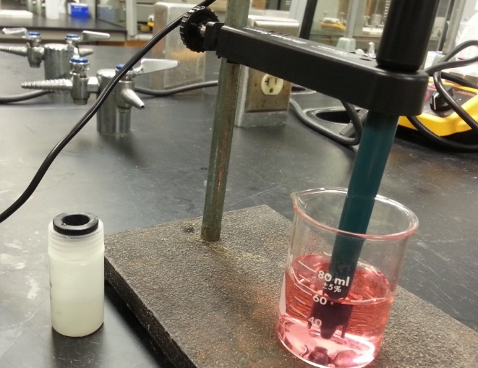
- Blot the electrode dry with a lab tissue. (That way, the extra liquid won’t dilute the solution being examined.) Place the electrode in the pH 4 buffer. Wait for the pH reading (at the lower left corner on the screen) to stabilize. Swirling the beaker in a circle seems to help stabilize the reading. (The reading won’t be exactly 4.0 until after the instrument is calibrated, which is the next step.)
Figure 1. pH Electrode in a solution. The electrode holder frees the hands. The storage bottle has an o-ring that stays with the bottle.
- Click “Experiment” >>> “Calibrate” >>> “Go!Link: 1 pH” as shown in the following figure. A window will pop up.
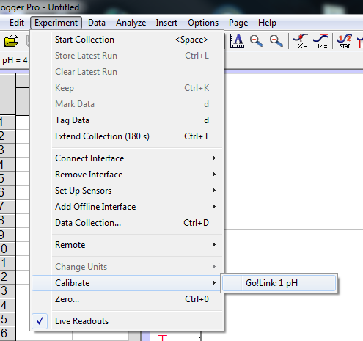
- In the pop-up window, click “Calibrate Now” button. Then, enter “4.0” in the blank below “Reading 1”, and click the “Keep” button below it.
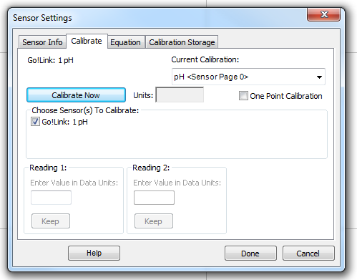
- Rinse the tip of the pH electrode with deionized water, dry it with a lab tissue, and place the electrode in the pH 7 buffer. The pH will not update, but the voltage will display in the dialog box. Swirl the beaker in a circle until the voltage reading stops changing.
- Then, enter “7.0” in the blank below “Reading 2”, and click the “Keep” button below it.
- Click the “Done” button. Now, you’ve finished the calibration of the pH electrode. Typically, a pH electrode only need to be calibrated once a day, which means the calibration you just did will be good for the whole lab and you don’t need to calibrate the pH electrode again in this lab period (unless the software is closed).

Initial Preparations
- Obtain the Unknown acid. Into a clean, dry 250 mL Erlenmeyer flask dispense about 180 mL of the unknown acid from the carboy labeled “Unknown Acid”. On the report sheet record the concentration of this unknown, which is also written on the carboy. Label the flask “X” (for unknown) (labeling tape may be on the front desk).
- Obtain sodium hydroxide (only used in Part II). Into a clean, dry 250 mL Erlenmeyer flask dispense about 140 mL of the NaOH solution from the carboy labeled “NaOH”. On the report sheet record the concentration of this solution, which is also written on the carboy. Label the flask “NaOH”.

Part I, K_{a} from the pH of an Acid Solution of Known Concentration
- Measure the pH of the unknown acid. Fill a 50 mL beaker about half-full with the solution of unknown acid. Record the actual molarity of that acid, which is written on the carboy. Read the pH and record it on the data sheet. Remove the electrode from the solution and thoroughly rinse it with distilled water using the wash bottle collecting the waste into the beaker. Discard the solution in the beaker into the waste container. Rinse the beaker with water.
- Calculate K_{a}. Fill in the ICE table on the data sheet following the example calculation in the introduction, except use the molarity of the unknown acid actually used, and use the pH value you measured to calculate [H⁺]. Calculate the K_{a} of the unknown acid and record on the data sheet.

Part II, K_{a} from Partial Neutralization
- Clean two 50 mL burets and a 100 mL volumetric flask by rinsing them out a few times with around 10 mL of deionized water.
- Rinse buret with unknown acid solution. Rinse one of the burets out with around 5 mL of the unknown acid solution. Tip the buret around so that the liquid contacts most of the buret wall. Pour the liquid out. Repeat with two more 5 mL portions.
- Adjust liquid level. Place the buret in the buret holder. Place a waste beaker under the buret to catch any liquid runoff if the buret is overfilled (which is easy to do). Using a funnel, fill the buret to above the 0 mL level with the unknown acid solution. Remove any air bubbles from the buret tip (to do this, give the buret a little downward “jerk” while the stopcock is open). Dispense liquid until the liquid level is below or at the 0 mL mark.
Do not try to get the liquid level exactly at the 0 mL mark. It is more accurate to record the actual initial level, rather than to try to get it exactly at zero, and call it “close enough”.
Remove the hanging droplet from the buret tip by touching the tip to the inside wall of the waste beaker. Determine this initial liquid level to 0.01 mL and record the buret reading on report sheet 1.
The size of the droplet on the tip of the buret is supposed to be the same at the start and at the end of dispensing liquid, so after dispensing liquid from the buret to another container, touch the tip to the inside wall of that container.
Caution: 0.5 M NaOH is caustic. If you get it on your hands, rinse them with water for at least a couple of minutes, until the skin no longer feels soapy. Wear goggles all the time when in the lab.
- Rinse buret with NaOH; adjust liquid level. Rinse and fill the other buret with the NaOH solution following the same procedure as before. Determine the initial liquid level to the nearest 0.01 mL and record this value in the report sheet.
- Prepare solution 1 by adding about 40 mL of the unknown acid solution from the buret to the 100 mL volumetric flask (cleaned in step 5). Determine the actual buret reading after delivering the liquid and record that level on the report sheet to the nearest 0.01 mL.
Then add about 12.5 mL of the NaOH solution from the other buret to the same volumetric flask. Read the buret to the nearest 0.01 mL and record the reading on the report sheet.
Dilute the contents of the 100 mL flask in two steps: First, dilute to the base of the neck with deionized water, then swirl to mix (or invert a few times). Second, fill up to the mark with deionized water from a wash bottle so that the bottom of the meniscus is at the same level as the mark. Stopper the flask. Invert the flask, swirl, turn back upright; repeat a total of three times.
You might wonder why the flask was not filled to the mark in one step. The reason is that the final volume when water and a concentrated solution are mixed may be more or less than the sum of the volumes. Suppose water was poured on top of a concentrated solution, and the flask was filled to the mark. On mixing the solution, the volume may increase (or decrease) a little: the flask may suddenly be above the mark. The behavior is avoided by filling with water in two steps: the first step dilutes the solution, so that water is added to a dilute solution in the second step, so the volume does not noticeably change on mixing.
Next, the pH of this solution will be measured, then three more solutions will be prepared.
- pH of solution 1. Pour about 25 mL of solution 1 into a clean, dry 50 mL beaker. Place the glass electrode in this solution. Read the pH and record it on Data Sheet 1. Remove the electrode from the solution and thoroughly rinse it with distilled water using the wash bottle collecting the waste into the beaker. Discard the solution in the beaker and in the volumetric flask into the waste container. Thoroughly wash the beaker and flask with distilled water. Keep the electrode from drying out by putting it in water in another beaker.
- Prepare solution 2. Use the amounts of reactants given below to prepare solution 2.
Solution Number | Volume of unknown weak acid / mL | Volume of 0.2 M NaOH / mL
1 | 40.0 | 12.5
2 | 40.0 | 25.0
3 | 40.0 | 37.5
4 | 40.0 | 50.0
- Measure the pH of solution 2 as in Step 10. Record this pH on Data Sheet
- Prepare solutions 3 and 4 and measure their pHs. Repeat the previous step two more times to prepare solutions 3 and 4.
- Calculate the K_{a} as shown in the second example, “K_{a} from Partial Neutralization”, in the introduction.
- Clean up. Leave the pH buffer solutions on the bench top for the next lab section, unless yours is the last section of the day, in which case discard the buffer solutions in the waste container. Discard all other solutions into the waste container and rinse all glassware used. Replace the glass electrode into the buffer storage solution. Log off of the computer.

